Polymorphic UML Sample Using an Abstract Super Class

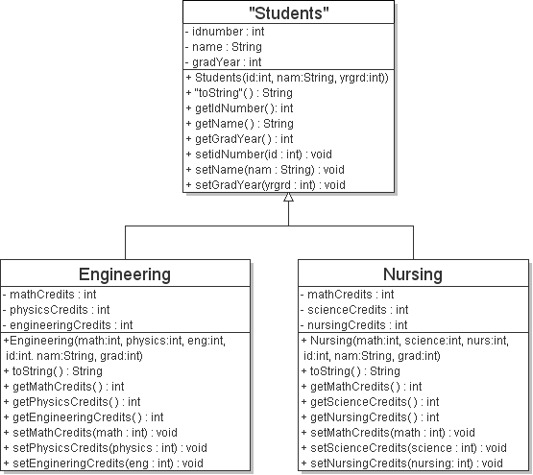

- Note that this is an example of polymorphism which uses both inheritance and an abstract class.

- The toString ( ) method in the Students class is abstract (not implemented) and is indicated with the double quotes (”) around the method name. Since Students has at least one abstract method, then it is an abstract class, and no objects can be instantiated from it. Notice how it is also enclosed in double quotes to indicate that it is an abstract class.

- The toString ( ) method is implemented in each of the sub classes and notice the lack of any double quotes around the method name. The code for the toString method in each sub class would return a String containing a description of the object with the name of the object and the values for all of the attributes.

- Since this is also an example of inheritance, each class has a constructor. Note how the constructors for the sub classes are passed all of the necessary parameters to instantiate a sub class object. The Java code for the sub class constructors would first call the super class (Students) constructor and pass it the id number, name, and gradyear. The sub class constructor would then initialize the three credit attributes.

